**3-Rotation**

Rotation about origin through an angle $θ$ is a transformation $T:R^{2}→R^{2}$ defined as:

$$T\left(\vec{x}\right)=A\vec{x} : ∀\vec{x}∈R^{2}$$

Where

$$A=\left[\begin{matrix}Cos(θ) & -Sin(θ) \\ Sin(θ) & Cos(θ)\end{matrix}\right]$$

* If the direction of $θ$ is not defined, then it is understood to be in anticlockwise direction.
* If $θ$ is in clockwise direction, then replace $θ$ by $-θ$ in the above definition as:

$A=\left[\begin{matrix}Cos(θ) & Sin(θ) \\ -Sin(θ) & Cos(θ)\end{matrix}\right]$

**Example 1:** Sketch the image of given rectangle with vertices A(0,0), B(3,0), C(3,2), D(0,2) under the rotation of $30^{0}$ (anticlockwise).

**Solution:** As the transformation of rotation is

$$T\left(\vec{x}\right)=A\vec{x} :∀\vec{x }∈R^{2}$$

Where

$$A=\left[\begin{matrix}Cos(θ) & -Sin(θ) \\ Sin(θ) & Cos(θ)\end{matrix}\right]$$

As $θ={30}^{0}$, so

$$A=\left[\begin{matrix}Cos({30}^{0}) & -Sin({30}^{0}) \\ Sin({30}^{0}) & Cos({30}^{0})\end{matrix}\right]=\left[\begin{matrix}\frac{\sqrt{3}}{2} & -\frac{1}{2} \\ \frac{1}{2} & \frac{√3}{2}\end{matrix}\right]$$

For point A: $T\left[\begin{aligned}0 \\ 0\end{aligned}\right]=\left[\begin{matrix}\frac{\sqrt{3}}{2} & -\frac{1}{2} \\ \frac{1}{2} & \frac{√3}{2}\end{matrix}\right]\left[\begin{aligned}0 \\ 0\end{aligned}\right]=\left[\begin{aligned}0 \\ 0\end{aligned}\right]$

For point B: $T\left[\begin{aligned}3 \\ 0\end{aligned}\right]=\left[\begin{matrix}\frac{\sqrt{3}}{2} & -\frac{1}{2} \\ \frac{1}{2} & \frac{\sqrt{3}}{2}\end{matrix}\right]\left[\begin{aligned}3 \\ 0\end{aligned}\right]=\left[\begin{aligned}\frac{3\sqrt{3}}{2} \\ \frac{3}{2}\end{aligned}\right]=\left[\begin{aligned}2.598 \\ 1.5\end{aligned}\right]$

For point C: $T\left[\begin{aligned}3 \\ 2\end{aligned}\right]=\left[\begin{matrix}\frac{\sqrt{3}}{2} & -\frac{1}{2} \\ \frac{1}{2} & \frac{\sqrt{3}}{2}\end{matrix}\right]\left[\begin{aligned}3 \\ 2\end{aligned}\right]=\left[\begin{aligned}\frac{3\sqrt{3}}{2}-1 \\ \frac{3}{2}+√3\end{aligned}\right]=\left[\begin{aligned}1.599 \\ 3.23\end{aligned}\right]$

For point D: $T\left[\begin{aligned}0 \\ 2\end{aligned}\right]=\left[\begin{matrix}\frac{\sqrt{3}}{2} & -\frac{1}{2} \\ \frac{1}{2} & \frac{\sqrt{3}}{2}\end{matrix}\right]\left[\begin{aligned}0 \\ 2\end{aligned}\right]=\left[\begin{aligned}-1 \\ 1.732\end{aligned}\right]$

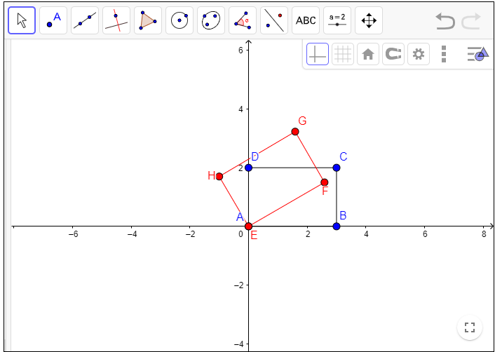

**Work to do:**

**Q1.** Sketch the image of given parallelogram with vertices A(0,1), B(3,0), C(5,-2),

D(2,-1) under the rotation of ${90}^{0}$ (anticlockwise) .

**Q2.** Sketch the image of given triangle with vertices A(2,4), B(2,2), C(4,2) under the

rotation of 9 $0^{0}$ (clockwise) .

**Example 2.** Lety = 2x+5 be a line. Find the equation of line after rotating it through

an angle of $\frac{π}{2}$ clockwise direction about origin.

**Solution:** The matrix of rotation in clockwise direction is

$$A=\left[\begin{matrix}Cos(θ) & Sin(θ) \\ -Sin(θ) & Cos(θ)\end{matrix}\right]$$

As $θ=\frac{π}{2}$, so $$A=\left[\begin{matrix}0 & 1 \\ -1 & 0\end{matrix}\right]$$

$$and T\left[\begin{aligned}x \\ y\end{aligned}\right]=\left[\begin{matrix}0 & 1 \\ -1 & 0\end{matrix}\right]\left[\begin{aligned}x \\ y\end{aligned}\right]$$

$$or \left[\begin{aligned}x' \\ y'\end{aligned}\right]=\left[\begin{matrix}0 & 1 \\ -1 & 0\end{matrix}\right]\left[\begin{aligned}x \\ y\end{aligned}\right] =\left[\begin{aligned}y \\ -x\end{aligned}\right]$$

$$or \left\{\begin{aligned}x^{'}=y \\ y^{'}=-x\end{aligned}\right. ⇒\left\{\begin{aligned}x=-y' \\ y=x^{'} \end{aligned}\right.$$

Put value of x and y in original equation of line $y=2x+5$ and obtain

$$y^{'}=-\frac{x^{'}}{2}+\frac{5}{2}$$

This is the rotated line with angle $\frac{π}{2}$ in clockwise direction.

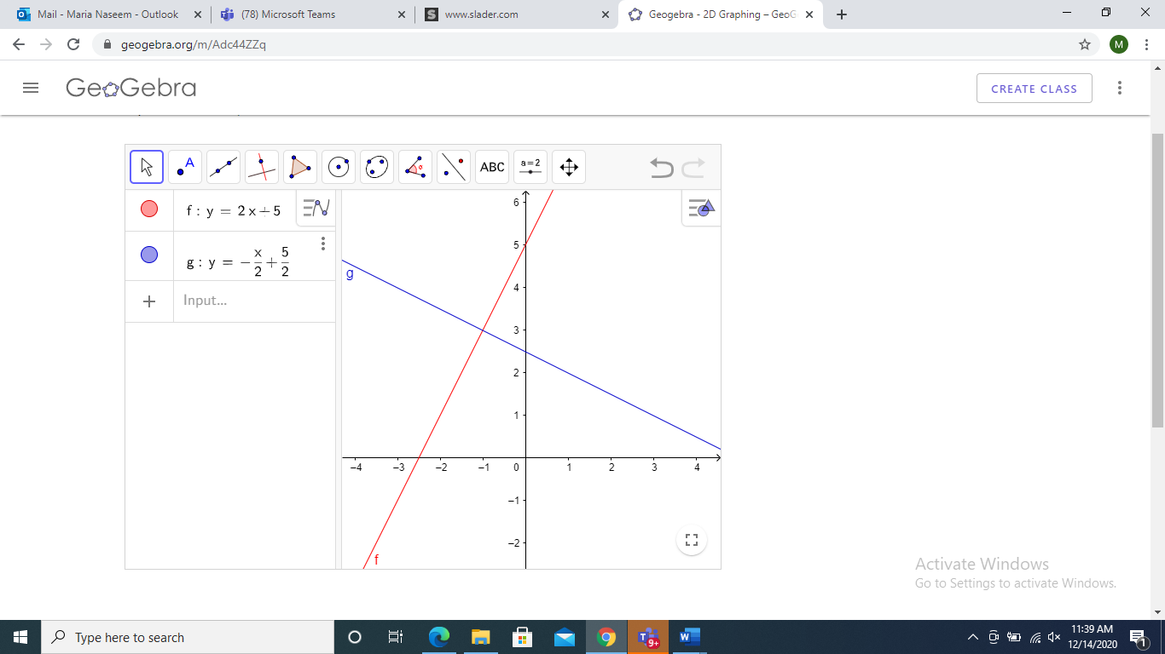

**Work to do:**

**Q3.** Let $y =-2x+7$ be a line. Find the equation of line after rotating it through an angle of ${180}^{0},{270}^{0}$ clockwise direction about origin.

**Example 3.** Let ${\left(x-4\right)}^{2}+{\left(y-3\right)}^{2}=9$ be a circle. Find the equation of circle after rotating it through an angle of ${90}^{0}$ in anticlockwise direction about origin.

**Solution:** The matrix of rotation in anticlockwise direction is

$$A=\left[\begin{matrix}Cos(θ) & -Sin(θ) \\ Sin(θ) & Cos(θ)\end{matrix}\right]$$

As $θ={90}^{0}$, so

$$A=\left[\begin{matrix}0 & -1 \\ 1 & 0\end{matrix}\right]$$

Therefore, for $T\left(\vec{x}\right)=A\vec{x } :∀ \vec{x}∈R^{2}$

$$\left[\begin{aligned}x' \\ y'\end{aligned}\right]=\left[\begin{matrix}0 & -1 \\ 1 & 0\end{matrix}\right]\left[\begin{aligned}x \\ y\end{aligned}\right]=\left[\begin{aligned}-y \\ x\end{aligned}\right]$$

Or $\left\{\begin{aligned}x^{'}=-y \\ y^{'}=x\end{aligned}\right.$ $⟹\left\{\begin{aligned}x=y' \\ y=-x'\end{aligned}\right.$

Putting these values of x and y in original equation of circle

$${\left(x-4\right)}^{2}+{\left(y-3\right)}^{2}=9$$

We get ${\left(x^{'}+3\right)}^{2}+{\left(y'-4\right)}^{2}=9$

This is the equation of rotated circle with angle $\frac{π}{2}$ in anticlockwise direction.

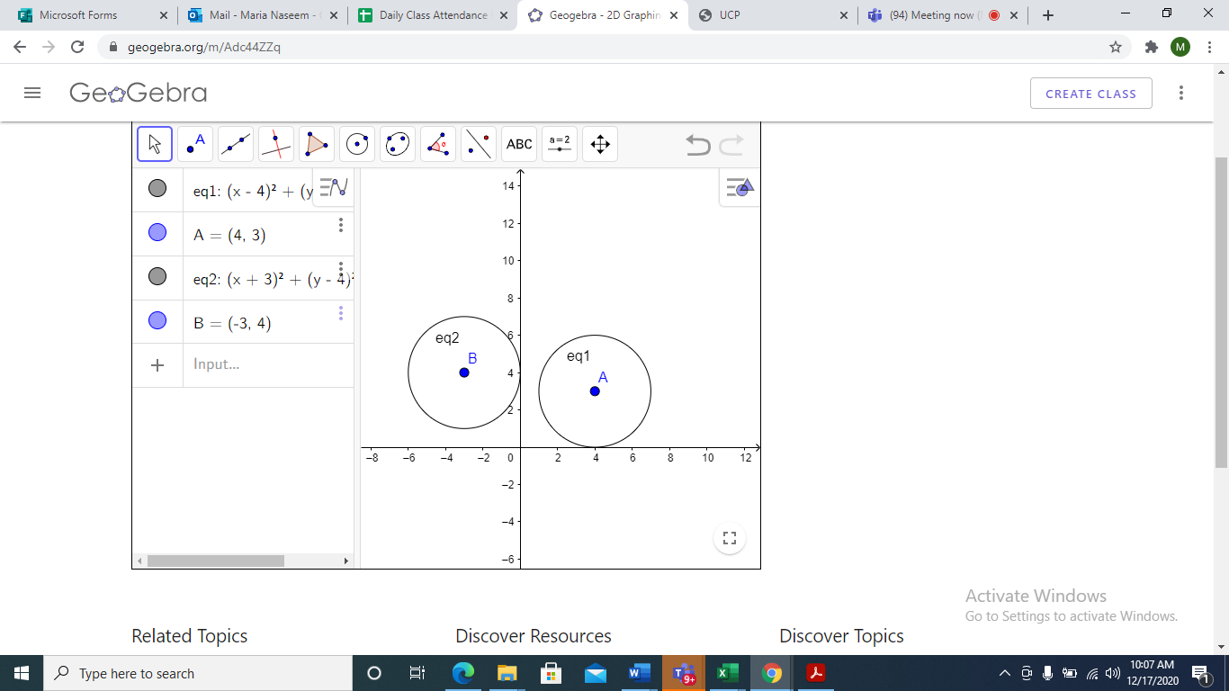

**Work to do:**

**Q4.** Let ${\left(x-4\right)}^{2}+{\left(y-3\right)}^{2}=9$ be a circle. Find the equation of circle after rotating it through an angle of ${180}^{0}, {270}^{0}$ in clockwise direction about origin.

**Example 4:** Let $\frac{x^{2}}{{\left(4\right)}^{2}}+\frac{y^{2}}{{\left(3\right)}^{2}}=1$ be an ellipse. Find the equation of ellipse after rotating it through an angle of ${90}^{0}$ in anticlockwise direction about origin.

**Solution:** The transformation of rotation in anticlockwise direction is

$$T\left(\vec{x}\right)=A\vec{x} :∀\vec{x }∈R^{2} \\ T(\vec{x})=\left[\begin{matrix}Cos(θ) & -Sin(θ) \\ Sin(θ) & Cos(θ)\end{matrix}\right]\vec{x}$$

As $θ={90}^{0}, \left[\begin{aligned}x' \\ y'\end{aligned}\right]=\left[\begin{matrix}0 & -1 \\ 1 & 0\end{matrix}\right]\left[\begin{aligned}x \\ y\end{aligned}\right]=\left[\begin{aligned}-y \\ x\end{aligned}\right]$

Hence, $\left\{\begin{aligned}x^{'}=-y \\ y^{'}=x\end{aligned}\right.$ or $\left\{\begin{aligned}x=y' \\ y=-x'\end{aligned}\right.$

Put these values of x and y in original equation of ellipse, we get the rotated ellipse with angle $\frac{π}{2}$ in anticlockwise direction as

$$\frac{{x'}^{2}}{9}+\frac{{y'}^{2}}{16}=1$$

For plotting we can neglect the dash $(‘)$ from our rotated equation of ellipse.

**Original Ellipse Rotated Ellipse**

$\frac{x^{2}}{16}+\frac{y^{2}}{9}=1$ $\frac{x^{'2}}{9}+\frac{y^{'2}}{16}=1$

**Major axis is along x-axis** **Major axis is along- yaxis**

$a=±4$, $b=±3 a=±3, b=±4$

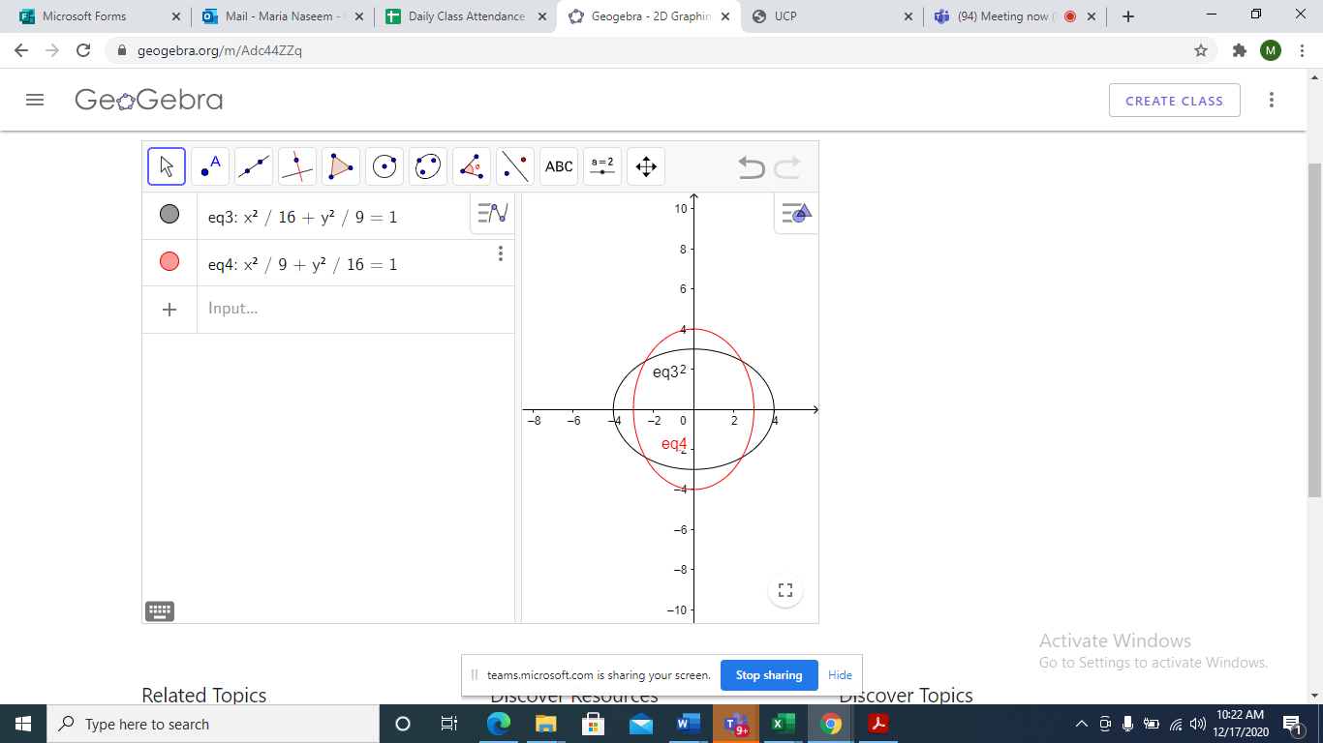

**Q 5.** Let $\frac{x^{2}}{9}+\frac{y^{2}}{16}=1$ be an ellipse. Find the equation of ellipse after rotating it through an angle of ${180}^{0}$ in anticlockwise direction about origin.

**Affine Transformations**

An affine transformation is a transformation $T:R^{2}→R^{2}$, defined by

$$T\left(\vec{x}\right)=A\vec{x}+\vec{a} ; ∀x∈R^{2}$$

For some $a∈R^{2}$, where $A$ is $2×2$ invertible matrix i.e. $AA^{-1}=I.$

**Types of Affine Transformation:**

1. **Scaling**

A transformation $T:R^{2}→R^{2}$, defined by:

$$T\left(\vec{x}\right)=A\vec{x}; ∀x∈R^{2}$$

Where

$$A=\left[\begin{matrix}k & 0 \\ 0 & k\end{matrix}\right]$$

Is said to be a scaling by the factor k.

**Note:**

1. If k>1, then its dilation/enlargement.
2. If $0≤k≤1,$ then its contraction.

**Example 1: (Scaling of Square)**

A square with vertices $\left(0, 0\right), \left(0,1\right), \left(1, 0\right), (1,1)$. Scale this square by factor 2.

**Solution:**

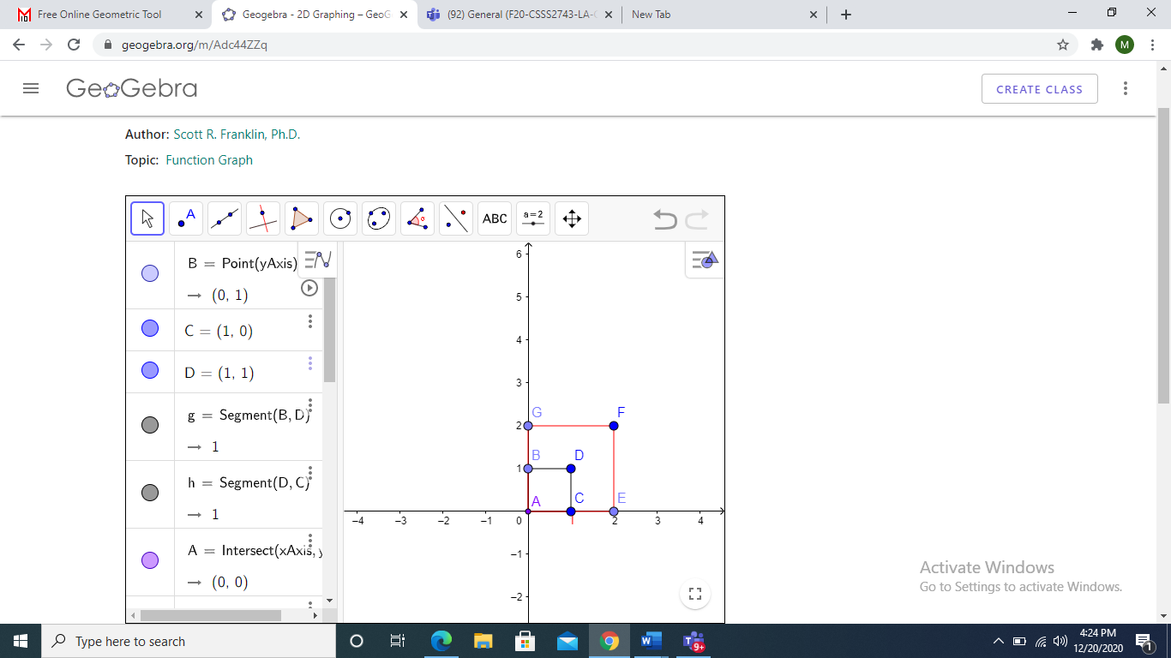As $T(\vec{x})=A\vec{x}:∀ \vec{x}∈R^{2}$

$$T\left[\begin{aligned}0 \\ 0\end{aligned}\right]=\left[\begin{matrix}2 & 0 \\ 0 & 2\end{matrix}\right]\left[\begin{aligned}0 \\ 0\end{aligned}\right]=\left[\begin{aligned}0 \\ 0\end{aligned}\right]$$

$$T\left[\begin{aligned}0 \\ 1\end{aligned}\right]=\left[\begin{matrix}2 & 0 \\ 0 & 2\end{matrix}\right]\left[\begin{aligned}0 \\ 1\end{aligned}\right]=\left[\begin{aligned}0 \\ 2\end{aligned}\right]$$

$$T\left[\begin{aligned}1 \\ 0\end{aligned}\right]=\left[\begin{matrix}2 & 0 \\ 0 & 2\end{matrix}\right]\left[\begin{aligned}1 \\ 0\end{aligned}\right]=\left[\begin{aligned}2 \\ 0\end{aligned}\right]$$

$$T\left[\begin{aligned}1 \\ 1\end{aligned}\right]=\left[\begin{matrix}2 & 0 \\ 0 & 2\end{matrix}\right]\left[\begin{aligned}1 \\ 1\end{aligned}\right]=\left[\begin{aligned}2 \\ 2\end{aligned}\right]$$

**Example 2: (Scaling of Line)**

Let $y=2x+3$ be a line. Determine the image of this line under the scaling by factor 3.

**Solution:**

As $T(\vec{x})=A\vec{x}:∀ \vec{x}∈R^{2}$

$$T\left[\begin{aligned}x \\ y\end{aligned}\right]=\left[\begin{matrix}3 & 0 \\ 0 & 3\end{matrix}\right]\left[\begin{aligned}x \\ y\end{aligned}\right]=\left[\begin{aligned}3x \\ 3y\end{aligned}\right]$$

$$\left[\begin{aligned}x' \\ y'\end{aligned}\right]=\left[\begin{aligned}3x \\ 3y\end{aligned}\right]$$

$\left\{\begin{aligned}x^{'}=3x \\ y^{'}=3y\end{aligned}\right.$ $⟹\left\{\begin{aligned}x=\frac{x^{'}}{3} \\ y=\frac{y^{'}}{3}\end{aligned}\right.$

Put value of $x$ and $y$ in original equation of line: $y=2x+3,$

And get the equation of scaled line with factor 3.

$$y^{'}=2x^{'}+9$$

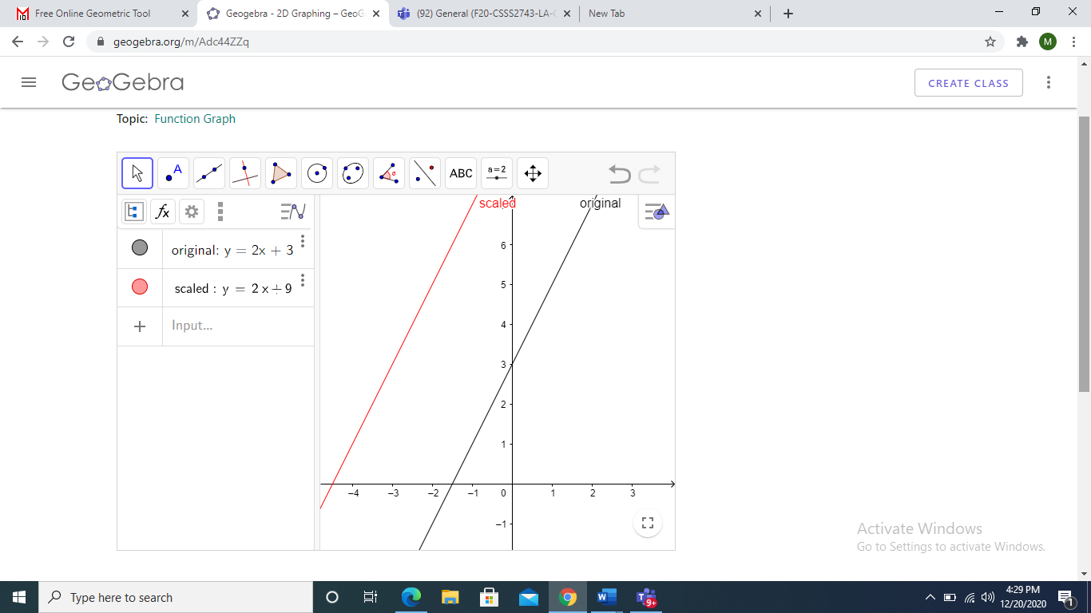

**Example 3: (Scaling of Circle)**

Determine the image of the circle

$$2^{2}.{\left(x-2\right)}^{2}+{\left(y-3\right)}^{2}=4$$

under the scaling by factor 2.

**Solution:** As $T\left(x\right)=Ax:∀ x∈R^{2}$

$$T\left[\begin{aligned}x \\ y\end{aligned}\right]=\left[\begin{matrix}2 & 0 \\ 0 & 2\end{matrix}\right]\left[\begin{aligned}x \\ y\end{aligned}\right]$$

$$\left[\begin{aligned}x' \\ y'\end{aligned}\right]=\left[\begin{aligned}2x \\ 2y\end{aligned}\right]$$

$\left\{\begin{aligned}x^{'}=2x \\ y^{'}=2y\end{aligned}\right.$ $⟹\left\{\begin{aligned}x=\frac{x^{'}}{2} \\ y=\frac{y^{'}}{2}\end{aligned}\right.$

Put value of $x$ and $y$ in original equation of circle: ${\left(x-2\right)}^{2}+{\left(y-3\right)}^{2}=4$, implies

$${\left(x^{'}-4\right)}^{2}+{\left(y^{'}-6\right)}^{2}=16$$

This is the equation of circle by factor 2.

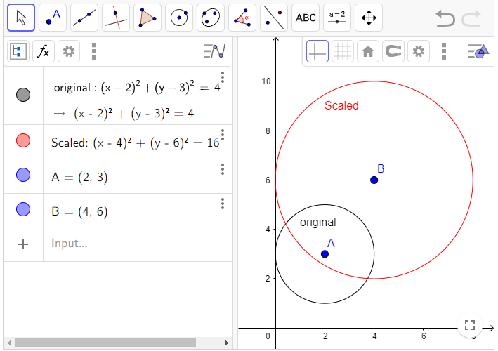

**Example 5:** (Scaling of an Ellipse)

Determine the image of an ellipse

$$\frac{x^{2}}{4^{2}}+\frac{y^{2}}{2^{2}}=1$$

under the transformation of scaling by factor 2.

**Solution:** As $T\left(x\right)=Ax:∀ x∈R^{2}$

$$T\left[\begin{aligned}x \\ y\end{aligned}\right]=\left[\begin{matrix}2 & 0 \\ 0 & 2\end{matrix}\right]\left[\begin{aligned}x \\ y\end{aligned}\right]$$

$$\left[\begin{aligned}x' \\ y'\end{aligned}\right]=\left[\begin{aligned}2x \\ 2y\end{aligned}\right]$$

$\left\{\begin{aligned}x^{'}=2x \\ y^{'}=2y\end{aligned}\right.$ $⟹\left\{\begin{aligned}x=\frac{x^{'}}{2} \\ y=\frac{y^{'}}{2}\end{aligned}\right.$

Put value of $x$ and $y$ in original equation of ellipse and get an ellipse scaled by factor 2.

$$\frac{x^{'2}}{64}+\frac{{y'}^{2}}{16}=1$$

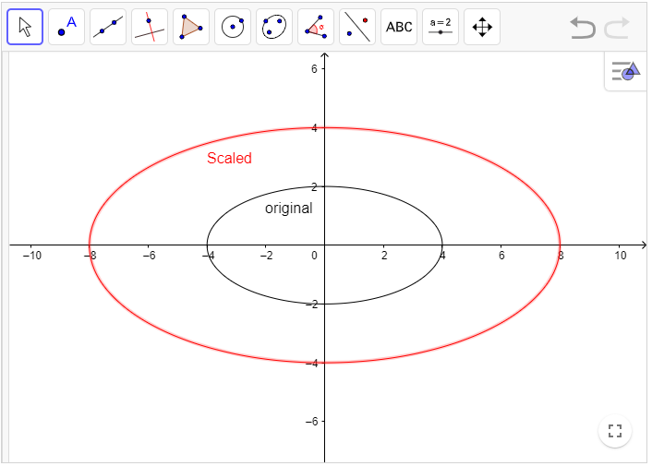

**Practice Problems**

Q1. Find the Image of a triangle with vertices A= (2, 2), B = (4, 3), C = (5,5), when these are scaled by factor 2.

Q2. Find the Image of line $y=2x+5$ under the transformation of scaling by factor 3.

Q3. Find the image of an ellipse $\frac{{\left(x-2\right)}^{2}}{4}+\frac{{\left(y-3\right)}^{2}}{9}=1$ under the transformation of scaling by factor 2.